UNIT 2 LANGUAGE USE
In this unit, you will learn to:
- use an appropriate tone
- eliminate wordy phrases
- delete unnecessary words and phrases
- convey information concisely and accurately

TONE IN BUSINESS COMMUNICATION

Communication tone is very important as it shows the sender's attitude towards his/her message and its receiver. A breakdown in communication can occur if an inappropriate tone is used. Tones in business communication messages can be categorized as being formal or informal, decisive or tentative, polite or rude, destructive or constructive, etc. Therefore, it is the sender's responsibility to employ the appropriate direction of communication and types of tone.

I. Direction of Communication

It is best to identify the relationship between the sender and the receiver before beginning to write. This will help to determine the suitable tone, which may be categorized as either upward, downward or horizontal.

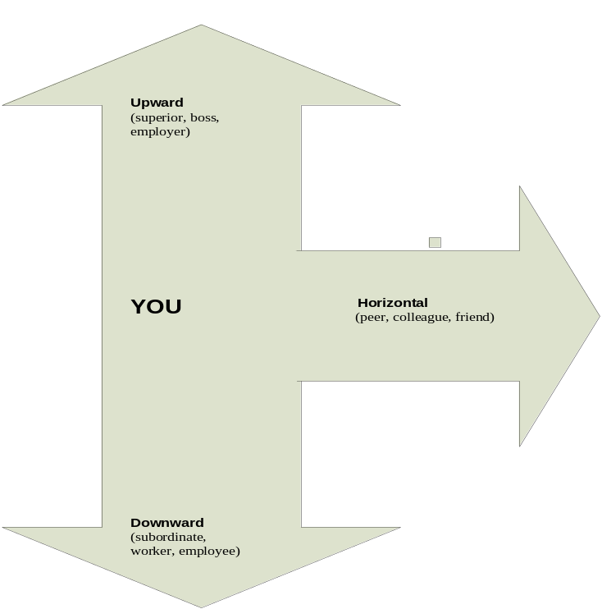

Upward Communication ( ↑ )

It is used when a subordinate communicates with a superior. The sentences are written in a respectful and tentative tone and they are usually longer as elements of politeness are incorporated. Upward communication is used for requests, suggestions, etc. and the tone is usually formal. For instance:

I would be most grateful if we have the meeting this Monday.

I would be extremely grateful if you could consider my application for leave.

Downward Communication ( ↓ )

It is used when a superior communicates with a subordinate. The sentences reflect a firm, certain or direct tone and they usually include decisive modals. Downward communication is used to issue orders, state decisions, etc. and the tone is usually formal. For instance:

All employees must attend the meeting this Monday.

Your application for leave is rejected.

Horizontal Communication ( ↔ )

It is used between people of equal authority and status such as colleagues, friends, etc. The sentences usually project a close, friendly or casual tone. Horizontal communication is used to make suggestions, requests, etc and the tone can sometimes be informal. For instance:

I would be grateful if you can come for the meeting this Monday.

Would you please forward my application for leave as soon as possible?

LANGUAGE USE IN BUSINESS CORRESPONDENCE

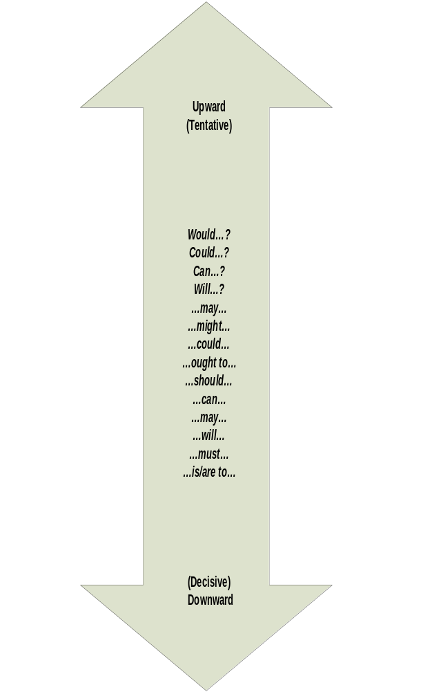

Modal verbs are usually used to express a particular aim. They are used to give permission, make suggestions, express ability, necessity, advice, probability, requests and etc. Modals are also used to differentiate the directions of communication. Thus, in order to express aims effectively, it is important to use suitable modal verbs.

II. Destructive or Constructive Tone

Apart from direction of communication, the use of suitable words is important in conveying messages. In order to achieve this, there is a need to empathize with the receiver. A writer should use words which suggest improvement or which guide the reader toward improvement. In addition, he/she should emphasize the aim of the message rather than the receiver's failure.

Destructive Tone

We regret to inform you that there is no possibility of approving your leave. Your punctuality has been unsatisfactory. You have also failed to fulfill the attendance requirement. Your application is rejected and will not go unrecorded.

Positive Tone

Congratulations for being the Best Sales Manager of the Millenium. You have increased the company's sales by 20 % and you have succeeded in convincing most of our clients. I would appreciate if you could attend the meeting this Monday to share your experience.

III. Reference Tones

The use of pronouns is frequent in business communication. However, it can convey different tones for various situations and messages. It can develop interest and sharing or on the other hand, create accusation. For example:

- Using only or mostly I, me, my and mine in the message can project a self centred attitude or tone. Thus, relationship can be affected.

My meeting is on this Monday. All must attend my meeting first. I want my report on the sales performance to be presented first.

2. Using you, your, yours with I, me, my and mine or we, our and ours can either bring together or bring apart the sender-receiver relationship.

Thank you for your comments. All of us need to meet to discuss the matter further. Let us have a meeting this Monday.

Your report is irrelevant and it does not meet our requirement. All of us need to meet and study the mistakes and problems in your report. You must attend the meeting this Monday to improve on your report.

STYLE IN BUSINESS COMMUNICATION

In writing business letters, care should be taken in making the letters as brief, concise and as clear as possible. This can be achieved by avoiding circumlocution and verbosity in sentences. In addition, messages should also be conveyed in as little words as possible.

I. Redundancy and Circumlocution

Redundancy

When writing business letters, clarity and accuracy must be taken into consideration. Redundancy is unnecessary repetition of words and phrases, whose meaning are already stated by other words. One way of expressing thoughts and ideas effectively is to remove redundancy in your writing.

Look at the two introductions to a letter below. Which do you think is clearer?

Paragraph A Paragraph B

Thank you for your letter dated 3 March 2000 Thank you for your letter dated
enquiring about our products and your interest 3 March 2000 expressing interest
in our products. We are very pleased to note in our latest range of ladies
that our latest range of ladies accessories has accessories.
caught your attention.

In the examples above, you can clearly see why Paragraph A is not as effective as Paragraph B. The reasons are:-

- In A, the phrase, “…..and your interest in our products” is redundant. If the sender is not interested in the products, he/she will not be enquiring in the first place.

- The second sentence repeats the same idea expressed in the first.

Needless repetition of words is a writing fault and to be effective when writing business documents, you should be aware of redundancy and avoid them.

Below are a list of common redundancies found in letters and their corrections.

Redundancy Correction

Advance warning Warning
Combined together Combined
Completely eliminated Eliminated
Consensus of opinion Consensus
Contractual agreement Contract or Agreement ( not both)
Due to the fact Because
Endorse on the back Endorse
Few in number Few
Fiscal financial year Fiscal year
For your information (should be deleted)
I am writing this letter (should be deleted )
In the event of If
In view of the fact that Because
Massively large Massive Or Large (not both)
Necessary prerequisite Prerequisite
New beginning Beginning
As per your request As you requested
Please find enclosed Enclosed
The above mentioned the above
This is to acknowledge (should be deleted)
This is to inform you (should be deleted)
This is to let you know (should be deleted )
We extend our grateful thanks Thank you for…..
You are hereby notified (should be deleted)

Circumlocution

Circumlocution is the tendency to say what one wishes to say in a long-winded or roundabout way. This usually results in saying what one wants to say in a mass of long expression rather than being as concise, direct and as clear as possible.

Types of Redundancy and Circumlocution

- Repetition of Words.

This is the simplest form of redundancy whereby a word is used to express
meaning already conveyed in the previous word.

Example: a) The report has been rewritten again.
The word again is redundant as the prefix “re” in the word “rewritten”
already indicated repeated action.)

b) The reason why the document was not signed is because the officer in
charge was on sick leave.
( Both why and because introduce the reason for an action and it is not
necessary to use both.)

c) I will refer this matter back to my supervisor.

- Stating the Obvious

This type of redundancy occurs when words are used to explain something which is obvious.

Example: a) The report will be faxed to you via the facsimile machine.

b) I, as the Sales Manager of Goon Sdn Bhd, am pleased to enclose
our latest catalogue for your perusal.
(Generally, the designation of the writer will be stated when he signs
the letter. Hence, the phrase in italics is redundant.)

c) Red in colour.

- Redundant Adjectives and Intensifiers.

Words, especially nouns and adjectives, sometimes do not need any modifiers because they explain themselves. To add adjectives to nouns that do not need adjectives and intensifiers to adjectives that do not need to be intensified result in redundancy.

Example: Redundant Adjectives

- massively large c) advance warning
- definite decisions d) serious dangers

Example : Redundant Intensifiers

a) very dead c) accurately correct
b) absolutely important d) exactly identical

- Wordy Prepositional Phrases

Wordy prepositional phrases may be replaced by their simple prepositional equivalents.

a. Wordy : I am writing to you in connection with your application…
Concise : I am writing to you about your application…

b. Wordy : Your estimate as to the number to be ordered …
Concise : Your estimate of the number to be ordered…

c. Wordy : Intercity approached the merger in a cautious manner.
Concise : Intercity approached the merger cautiously.

- Long Lead-ins

Delete unnecessary introductory words.

a. Wordy : You will be interested to know that you may now use the
automatic teller at our Bangsar branch.
Concise : You may now use the automatic teller at our Bangsar
branch.

b. Wordy : I am sending this announcement to let you all know that the
office will be closed Friday.
Concise : The office will be closed this Friday.
c. Wordy : It has been brought to my notice that you have been late to
meetings.
Concise : We have noticed that you have been late for meetings.

6. Wordy Phrases

Avoid : as/so far as … is concerned
from … viewpoint/angle/point of view
in view of/owing to/in spite of/the fact that
in the event of
for the purpose of

- Wordy : The position is not attractive from the renumeration
viewpoint.
Concise : The post is not well paid.

b. Wordy : In view of the fact that your application was not received
before the deadline.
Concise : As your application was not received before the dateline.

c. Wordy : We have purchased that for the purpose of simplifying our
task.
Concise : We have purchased that to simplify our task.

7. Excessive use of Passive

In order not to use excessive words, use active rather than passive forms of the verbs. Active voice is also more vivid and easier for the reader to picture mentally. However, in passive voice sentences, the doer is usually not mentioned thus making the sentences rather abstract.

- active : En.. Bakar will pay this account next month.
passive : Payment of this account will be paid by En. Bakar next
month.

b. active : The supervisor supervised the machine operators at the
production floor.
Passive : The machine operators are being supervised at the
production floor.

8. Verbosity and Outdated Expressions

Verbosity refers to the attempt to accumulate words to make the material seem important or to impress the reader. This would result in a disproportion between the number of words and the amount of information conveyed

- Wordy : I would like to take this opportunity to congratulate you on
promotion.
Concise : Congratulations on your promotion.

b. Wordy : In the event that the shipment does not arrive on time…
Concise : If the shipment is late …

c. Wordy : In view of the present field conditions, attributable to the
continuous rain, staff responsible for competitive matches,
may find it advisable to pay particular attention to this
aspect with view in deciding in connection with any
particular activity whether it can be proceeded with safety
or should be postponed.
Concise : During the present rainy season, staff responsible for
matches should assure before starting the game that the
field can be used with safety or should the match be
postponed.

Outdated expressions mean using formal and flowery expressions to convey
ideas. These expressions not only lengthen the letter but also confuse the
readers. Read the two paragraphs below. Which do you think is clearer?

Paragraph 1  We are taking the liberty of sending you the article “How to maximize Staff’s productivity” for your convenience, Pursuant to your request, we trust you will find it useful and would be extremely grateful if your goodself would inform the undersign of the receipt of this article. |  | Paragraph 2  We are sending you the article “How to maximize staff’s productivity” as requested. Please acknowledge receipt of the article.

It is quite obvious that Paragraph 2 is definitely more precise. Avoid using time worn, stale expressions and replace these with more direct and concise wording. This will overcome the problems of confusing the reader and also the excessive use of words.

Below are some outdated expressions which should be avoided.

Outdated Expressions Modern Phrasing

….are in receipt of….. have received
attached hereto attached
enclosed herewith enclosed
kindly advise please write
pursuant to your request at your request or as requested
under separate cover separately
I offer for your kind consideration Please consider
I trust that I believe
Each month henceforth Each month
Take leave of absence on leave
You are herein informed that the The above report………
above mentioned report………

9. Sentence Length

Economy in sentences is a relation between the number of words and the amount of meaning they convey. Therefore, a sentence is not considered economical because it is short, or wordy because it is long. The test is not in the number of words but the amount of information they convey.

a. Wordy : As we walked in the direction of home, I felt as if I had
never been happier.
Concise : As we walked home, I felt I had never been happier.

b. Wordy : We find the situation in the city that exists at the moment
intolerable.
Concise : We find the present situation in the city intolerable.

c. Wordy : The years which preceded the time when Japanese troops
were withdrawn from Malaya were a time when there was
much social and political unrest among the people in this
country.
Concise : The years preceding the withdrawal of Japanese troops
from Malaya were a time of social and political unrest in
the country.

Study the memo below. What is wrong with it?

WEST SPORTS CLUB

MEMORANDUM

To : Secretary, West Sports Club
From: President
Subject: Urgent EXCO Meeting

For your information, an unpleasant incident occurred at the premise of our sports club last night. Fighting and rowdy behavior broke out between two registered members.
An (untoward/unpleasant) incident occurred at the club between two members last night (date).

As President of this club, I feel that it is imperative that a meeting be convened and held immediately in our meeting room to discuss about the unpleasant and unfortunate incidents that happened in our sports club, and then to adopt strict and controlled measures to curb this rowdy and unacceptable behavior, so that no untoward incident would recur again.
We need to meet on (date/time/venue) to discuss measures to prevent this incident/unacceptable behaviour from happening again.

I would appreciate it very much if you could send out and disseminate a notice of the meeting as soon as possible.
Please send out a notice of meeting by (date)
Thank you.

Alvin Tan

For your information
should be omitted as
it is a redundant phrase.

Fighting and rowdy

behavior are repetition of

words conveying
the same idea.

As President of this club
is redundant.

…in the meeting room
should be omitted as it
is stating the obvious.

Convened and held,

unpleasant and unfortunate,

strict and controlled,

recur again and send out

and disseminate are
all repetition of words.

10. Unity in Sentences / Sentence Connection

In any written text, the relationship between sentences is very important. If the readers cannot understand how the ideas in the sentences fit together, then chances are they will not be able to understand what the writer is saying. To help readers understand how ideas connect with each other, a number of words and phrases are used. These are called linkers.

Read the following text and take note of the words and phrases in bold.

Although best known for its technological expertise, large-scale international projects and giant ventures, Nippon Steel does not neglect its responsibilities as a corporate citizen. The company has a clear goal, that is, to harmonize its business activities with environmental protection development of the local economies where it does business.

Although : this word is used to link two ideas where one of them is unexpected
in relation to the other.
That is : this phrase is used to illustrate the point stated in the other sentence.

These two are example of linkers, a device used to create unity, coherence
and logical sequence in texts.

Below is a list of some of the linkers and their functions:

To indicate sequence To indicate examples To indicate alternatives

Firstly, secondly, thirdly For example, such as Alternatively, or
Before, after For instance, like On the other hand
Then, subsequently Instead, or rather
Finally, lastly

To indicate similarity To indicate contrast To indicate condition

The same as Whereas, In contrast Otherwise
Similarly Conversely, Contrary to Unless
Likewise However, Nevertheless If
In the same way Although, But Provided that
Correspondingly In spite of, Despite On condition that

To indicate Causes To indicate Effects To indicate additional
Since , because Therefore, Hence ideas.

Study the sentences in both columns A and B. Which do you prefer and why?

A | B
The Government has imposed protective tariffs.  The Government wants to stop the flood of cheap imports which threatened the domestic industries. | The Government has imposed protective tariffs because it wants to stop the flood of cheap imports which threatened the domestic industries.
The production departments use computers to monitor the supplies of raw materials.  The accounting departments use computers to process details of accounts. | The production departments use computers to monitor the supplies of raw materials and the accounting departments use them to process details of accounts.
The airport was closed due to fog.  Many incoming flights have to land elsewhere. | The airport was closed due to fog, therefore many incoming flights have to land elsewhere.
The Government wants to protect the environment.  The Government has introduced stringent environmental regulations. | The Government has introduced stringent environmental regulations in order to protect the environment.
Insurance is an option.  We strongly recommend it. | Although insurance is an option, we strongly recommend it.

LETTER FOR ANALYSIS

Read the following letter. What is wrong with it? Rewrite the following letter using the correct tone and style.

MegaTRend FASHION
23-A BLOCK C 5TH FLOOR WISMA KEBANGSAAN JALAN LAKSAMANA MELAKA Tel : 06-344 5678 Fax: 06 – 344 5679

5 January 2001

Mr Kelvin Khor
Kelvin Designs
4C Boutique Place
Jalan Bukit Cahaya
Kueal lumpur

Dear Mr Khor

I, as the Marketing Executive of MegaTRend and on their behalf, am writing to express interest in your wonderful and latest “Fresh Teens” designs which were presented at the recent Super Teens Fashion Parade.

We have been in the fashion business for 10 years and have only dealt with adult fashion. To move with the times, our directors have decided to launch a new range of children and teens fashion as the most fashion conscious people today are the teenagers and young mothers with small children. We are very impressed with your design, which we have had the pleasure of viewing at the Super Teens Fashion parade, and we are wondering if you would be interested in becoming the designer for our new Teens Fashion Department. We would be extremely fortunate if a professional, such as your goodself, with an excellent reputation in the fashion industry, would design for our new Teens Fashion Department in our establishment.

We would be grateful if you would let us know of your decision as soon as possible and we look forward to a favorable reply from you.

Yours sincerely

Susanna Chew
Marketing Executive
MegaTRend Sdn Bhd

